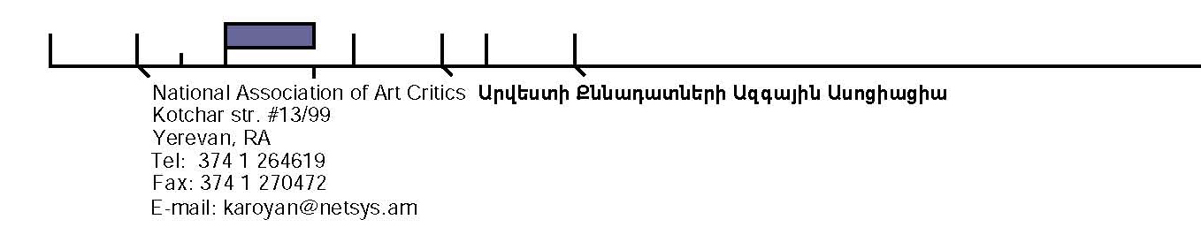

SUMMER SCHOOL FOR CURATORS: NEW CHALLENGES IN ART

NATIONAL ASSOCIATION FOR ART CRITICS

Applicants are advised to check the notes for guidance and eligibility information before completing this application. Use black ink, typed letters and tick the boxes where appropriate.

PERSONAL DETAILS

1. Surname/Family Name 2. First Names 3. Title (Ms., Mr., etc)

4. Date of Birth 5. Sex 6. Nationality 7.Country of Permanent Residency

DD MM YY MALE FEMALE

8. Home Address 9. Correspondence Address (if different)

Postcode
Tel.

Fax

E Mail

Postcode
Tel.

Fax
E Mail
Dates When the Address is Valid
10. EDUCATION – QUALIFICATIONS ALREADY OBTAINED OR YET TO BE TAKEN

NAME OF THE UNIVERSITY/COLLEGE AND/OR AWARDING BODY | START DATE  (MONTH/  YEAR) | END DATE  (MONTH/  YEAR) | QUALIFI  CATION  (BA, MA, ETC.) | OVERALL CLASS/ GRADE/GPA | DEGREE TITLE

12. ENGLISH LANGUAGE

Is English your fist language?

YES NO

If “NO” detail any education, work experience or qualification exam that you have undertaken in English. If available, enclose a copy of any certificate with your application.

13.EMPLOYMENT
You may attach your curriculum vitae if more convenient

NAME AND ADDRESS OF EMPLOYER | START DATE | END DATE | POSITION HELD AND MAIN DUTIES

14. PERSONAL STATEMENT
Describe you academic/career interests and give your reason for applying to the summer school. If necessary, attach separate sheet.

FUNDING
15. ARE YOU ABLE TO SECURE PERSONAL/FAMILY FUNDS FOR ATTENDING THE SUMMER SCHOOL?

YES NO

16. ARE YOU PLANNING TO APPLY (HAVE YOU APPLIED) FOR EXTERNAL FUNDING?

YES NO

If “YES”, provide any details about the funding body.

NAME OF AWARD VALUE OF AWARD HAS IT BEEN AWARDED?
YES DECISION PENDING

17. DO YOU WISH TO BE CONSIDERED FOR A FINANCIAL AWARD FROM NAAC?

YES NO

16. REFEREES
1. 2.
NAME: | NAME:
POSITION: | POSITION:
 | ADDRESS:
TEL.: | TEL.:
FAX: | FAX:
E-MAIL: | E-MAIL:

APPLICANT’S DECLARATION

To the best of my knowledge, the information provided is accurate and complete (Please, note that NAAC reserves the right to reject the application should it be discovered that the data provided is false or incorrect. If your application is accepted, you will be required to provide evidence of your qualifications.

Signature----------------------- Date

Please, read the guidelines to find out where to send your application package.

